**PRACTICAL-11**

**AIM:**

Demonstrate wireless communication between peer computer using Omnet++

**THEORY:**

**Omnet++:**

* Omnet++ stands for “Objective Modular Network Testbed in C++”
* It is a modular, component-based C++ simulation library and framework, primarily for building network simulators.
* **OMNeT++** is a simulation platform for discrete-event systems.
* Even though it is primarily targeted at simulating computer networks and distributed systems, it cannot be used without any extensions for wireless communication

**PRACTICAL IMPLEMENTATION:**

* Firstly, create a new project in omnet++.
* Create .ned file in source folder.
* Then, in this practical, we will code the topology.
* So, the code is below:

**package** wireless;

*//*

*// TODO auto-generated type*

*//*

**simple** client

{

**@display**("i=device/wifilaptop;p=230,45");

**gates**:

**input** radioIn **@directIn**;

}

**simple** server

{

**@display**("i=device/wifilaptop;p=230,45");

**gates**:

**input** radioIn **@directIn**;

}

**network** Topology

{

**submodules**:

server: server {

**@display**("p=207,90");

}

client:client{

**@display**("p=100,90");

}

}

**TOPOLOGY looks like:**

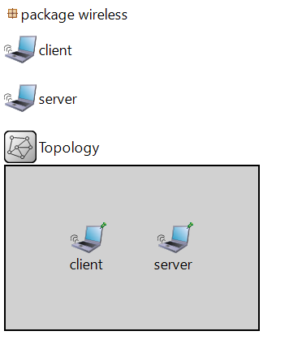

* Now, we will create 2 source files.
* File 1: client.cc:

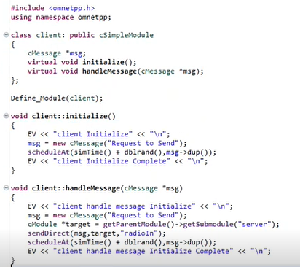

* File 2: server.cc:

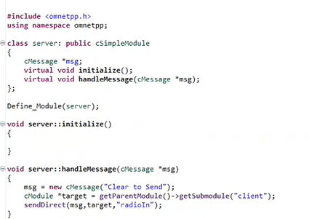

**OUTPUT:**

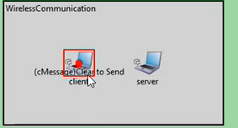

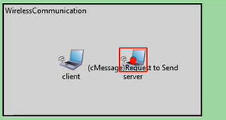

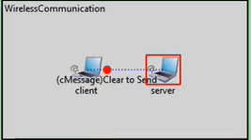

**CONCLUSION:**

* By performing the above practical, we learnt how to configure wireless topology and how to make it work in omnet++.